



**Hotel Management Software Development Project**

**[Deliverable 5: Prototype UI & Client Comments]**

**OCTOBER 26th, 2022**

**Client Information :   
Hôtel Manoir Ramezay – Vivian (Proprietor)**   
*492, rue Claude de Ramezay (Route 227),   
Marieville (Québec) J3M 1J6*  
Telephone : (450) 460-3251 | E-mail: [info@manoirramezay.com](mailto:info@manoirramezay.com)



**CERTIFICATIONS**:

I, Red Team LEADER, **Chi-Tao Li # 9730157**, certify that I have contributed to this deliverable.

Signature:  Date: 2022-10-26

I, Red Team MEMBER, **Li Yu # 2295012**, certify that I have contributed to this deliverable.

Signature:  Date: 2022-10-26

I, Red Team MEMBER, **Patrick Larocque # 0879202**, certify that I have contributed to this deliverable.

Signature: 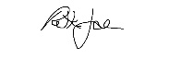 Date: 2022-10-26

I, Red Team MEMBER, **Murat Osmonov # 219501**, certify that I have contributed to this deliverable.

Signature: 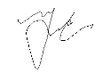Date: 2022-10-26

I, Red Team member, **Gerasimos Vlassopoulos # 2295049**, certify that I have contributed to this deliverable.

Signature: 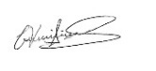 Date: 2022-10-26

|  |  |
| --- | --- |
| Table of Contents |  |
| 1. **Statement of Prior Work ……………………………………………** | **3** |
| 1. **Executive Overview ………………………...……………….……….** | **4** |
| 1. **Summary Narrative of the Project ….………….……………..…....** | **5** |
| 1. **Description of the Business Problem …………………….………....** | **6** |
| 1. **Usability Guidelines with Explanations ……………………………** | **8** |
| 1. **Copies of Prototype Interface ………………………………………** | **13** |
| 1. **Client Comments …………………………………………………….** | **21** |
| 1. **Description of Prototype Changes ………..………………………...** | **22** |
| 1. **Appendix 1 – Revised User Stories …………………………............** | **23** |
| 1. **Appendix 2 – Revised User Story Tests ………………………….....** | **27** |
| 1. **Appendix 3 – Revised User Story Map …………………………......** | **39** |
| 1. **References/Bibliography …………………………………………….** | **42** |

1. **Statement of Prior Work**

The work herein is possible in part due cumulative learning assignments and projects undertaken in the past, as part of the team’s Software Development curriculum. As such, some of the ideas or technical skills used in this project originate partially from prior work. The table below lists past projects undertaken by members of the Red Team, which may contribute in part to elements found in the scope of this project.

|  |  |  |
| --- | --- | --- |
| Past Projects | Tools Used | Contributor(s) |
| Mock-ups for personal websites, Application Dev 1 | Adobe Photoshop, Cava, Figma | All membres |
| Simulation Program | Java and Java Swing | Chi-Tao Li |
| Car Rental System | MS SQL Server | All members |
| Inventory Management System | Apache Derby Database, Java, and Java Swing | Patrick Larocque |
| Issue Tacker | C#, Google API, .NET, Firebase | Patrick Larocque |
| Added Prior Works  used for this deliverable | Tools Used | Contributor(s) |
| Deliverable 1 Report | MS Word, Instagantt.com (for Gantt Chart) | All members |
| Deliverable 2 Report | MS Word | All members |
| Database course | Draw.io, Lucidchart | All members |
| Deliverable 3 Report | MS Word, Draw.io | All members |
| Deliverable 4 Report | Miro | All members |

1. **Executive Overview**

The following document outlines the red team’s efforts and activities aimed at collecting system requirements for a new information system, designed to solve the business problems that is identified throughout the scope of this project. These requirements were gathered through a series of interviews with Manoir Ramezay.

Using the existing User Stories from the previous deliverable, we modified it to develop a revised version of the User Story Map based on our future information system. We were always in contact with the client as we revised the User Stories, Acceptance Tests, and User Story Map. From there, we developed hand-drawn prototypes in front of the client and later developed a digital version of the prototype based on the client’s comments. Throughout this deliverable, the process used to interact with the client will be mentioned. Overall, many of the tasks, actions and features built into the system will be derived from these User Stories that were gathered over the course of this deliverable.

As with previous reports, the reader will find a statement of their business problems. Next, the reader will find a summary narrative description of the project, indicating what has changed or has been added since the last deliverable. In addition, we’ve applied 10 usability guidelines and their explanations for the prototypes that were designed for the client. A copy of these prototype interfaces is included in hand-drawn and digital format.

1. **Summary Narrative Description of the Project**

What has changed mainly, are the tasks, as they must be real actions in the system. Therefore, we had to revise the User Stories and Tests. Based on the last two deliverables, there was a lot of back and forth with the client which led to our new findings. As a result, the User Story Map has slightly changed as well.

Given that third party booking platforms provide inherent discoverability for the hotel, along with familiar and immediate ways for potential guests to book through the platforms they are familiar with, the proposed information system will only be a business facing tool to be used by hotel staff to retrieve up-to-date room availabilities through an API. The system will also allow hotel staff to complete reservation requests made by guests booking directly through the hotel, by phone, email, walk-in or through the hotel’s website.

The Red Team has identified two primary roles relevant to the system. The first role is the receptionist, who will function as a generic user. The receptionist needs basic authorization, sufficient to create, modify and delete reservations, as well as browse, and update availabilities. The second role is a manger role. The manager will have admin privileges within the system. In addition to being able create, modify, and delete reservations, as well as read and update availabilities, the administrator will be able to create, read, update, and delete users on the system. The administrator will be able to manage user privileges, and the scope of their access to the system.

Both the user and administrator will begin at a login screen, where they will enter their usernames and password. Should they enter valid credentials, they will be logged in, and taken to the home screen with account privileges matching their account credentials. Should they enter invalid credentials, they will be shown an error message. Upon a successful login, the system will initiate API calls to retrieve up-to-date availabilities from third-party booking platforms. As a note, different screens will be used for the administrator as compared to the receptionist, and this is seen after the log in.

Once at the home screen, the user and the admin both will see some statistics amount the day’s availabilities. The user will have the option to navigate to a reservation’s menu, allowing the user to create a new reservation. Initiating a new reservation will also necessitate payment functionality. They may navigate to a calendar view of the month’s current availabilities. Another view option would be in a form of a list that shows either past, current, or future reservations. From here, the user may be able to search, modify, or delete reservations. There will be a button to refresh availabilities, which will make a series of new API calls to retrieve the most up-to-date booking history. The administrator will have access to the same functionality, however, they will additionally be able to navigate to a user’s tab, where they will be able to create, read, update, or delete users. At any moment, the user and the administrator both should be able to exit the application by clicking a button.

1. **Description of the Business Problem**

Hotel Manoir Ramezey doesn’t have an efficient system in place to keep track of room availability across available booking channels. When a room is booked through one of their platforms, the front- desk staff must update a physical ledger or print out a confirmation from their e-mail sent by a third-party platform, to have a unified running tally of past reservations. The front desk staff must then manually change room availabilities across all other platforms to avoid duplicate bookings and to reflect the actual availability. This is a very inefficient process, especially when the hotel is busy, during the summer months. The front-desk staff is often preoccupied with assisting on-site guests and fulfilling requests, so much so that they are unable to keep up with the current methods of data entry. This is a potential risk for double bookings and in overworked front-desk staff. This may lead to poor experience for the guests, leading them to choose another establishment in the future. Moreover, if a repeat guest returns to the hotel to book a room, the front-desk staff must reference the physical ledger or paperwork to find their personal information or preferences (if any were noted). This often leads to the client having to repeat much of the same information that was given during their prior visits.

As it stands, the current business problem has to do with efficient booking management. The current process is inefficient, leading to inaccurate room tallies, overworked front-desk staff, an inability to answer guests’ questions and the potential for poor experience as a result. Writing down all guests’ information on paper is a slow and error prone process and appears to be a pain point with respects to the hotel’s day to day operations. Booking and client information is spread across many tools and platforms, each needing to be cross-referenced every time a booking is made. This creates a bottleneck for the business if it wishes to continue growing.

Front-desk staff needs to be able to quickly verify the guests’ personal information for the check-in and check-out process. This will allow the hotel to stay in control of their bookings and automate repetitive tasks. It is important to the staff to have a real time calendar with up-to-date room availabilities, allowing for quick searching, modifying and deletion of guests’ and reservations. This will improve the experience for repeat guests especially, and if it will allow the staff to work in a more efficient and organized manner. A group booking feature with bulk reservation set-ups may also be a worthwhile addition, given that the hotel often books groups.

Moreover, the proposed information system should integrate with, rather than replace   
existing third-party booking options, as these third-party platforms provide inherent discoverability for the hotel. These platforms are familiar to prospective guests and their functionality is not redundant. Therefore, the proposed application should focus on solving the problem of interconnectivity and intercommunication between booking channels.

1. **Usability Guidelines with Explanations**

**Guidelines for a Good User Experience**

1. A CLEAR PURPOSE

A website must accommodate the needs of the user. The intention and purpose need to be simple and clear on all the pages to help the user interact with what the website has to offer. The intention of the website must be obvious at first glance.   
[(9 Principles of Good Web Design, 2021).](https://www.feelingpeaky.com/9-principles-of-good-web-design/)

1. A CONSISTENT AND SIMPLE COLOR SCHEME MATCHING COMPANY BRAND

Simplicity through a website design can be achieved by the website’s use of color. Color has the power to communicate messages and evoke emotional responses. Sticking to the minimal color scheme that matches with the business’s brand is ideal as to not distract the user. Furthermore, when creating hyperlinks and/or call-to-action links (CTAs), differentiating the colors from the rest of the text enhance the user experience. A call-to-action is content intended to induce a viewer, or reader to perform a specific act, typically taking the form of a directive. [(9 Principles of Good Web Design, 2021).](https://www.feelingpeaky.com/9-principles-of-good-web-design/)

1. USING RELEVANT AND HIGH-QUALITY IMAGES

High-quality and relevant images enhance the user’s experience positively. A poor designed or irrelevant imagery can be harmful to sales, sign-ups, and the overall brand of the company. Now-a-days, displaying low-quality and/or irrelevant images may cause confusion and distract the user. Proper imagery engages the users and it is a tool to clearly communicate the company’s brand message [(Barraclough, 2021).](https://www.expertmarket.co.uk/web-design/web-design-mistakes-to-avoid)

1. PROVIDING A SECURE WEBSITE  
    Users tend to avoid visiting questionable websites because of cyber security risks. A secure website should have an SSL certificate (or a lock icon) on the top left corner of web browser. These certificates encrypt data sent between a site and its user, ensuring that everything stays safe from cyber criminals from stealing user’s personal data [(Barraclough, 2021).](https://www.expertmarket.co.uk/web-design/web-design-mistakes-to-avoid)
2. USING READABLE TYPOGRAPHY  
    Typography should be comfortable to read. Resizing the size of the text to suit the user’s preference is ideal. Screen readers appreciate the comfort that a well-laid out and legible text provides. Reading requires enough cognitive effort, and there is no need to make reading harder. One way to approach a readable typography is to use contrast (for example: dark colored text on white background). Another approach is using an appropriate type-scale on headlines to ensure that the headings have enough visual weight and making the content easy to read. Breakdown of large blocks of text into smaller paragraphs create an easy read as well. Lastly, using fonts with good geometry and balanced letter spacing makes a readable typography for the user. [(Pop, 2022).](https://teleporthq.io/blog/design-tips-for-creating-a-good-user-interface)
3. PROPER USE OF WHITE SPACE  
    White space is the ‘negative’ space between the layout elements, paragraphs, and visual components. Designing with white space in mind will make the content more scannable, digestible, and easier on the eyes. White space is vital for visual separation. It conveys which elements belong together and which are different from one another. White space is a great tool for directing the eye towards essential elements [(Pop, 2022).](https://teleporthq.io/blog/design-tips-for-creating-a-good-user-interface)
4. CONSIDERING SITE SPEED   
    Site speed is an important part of the overall user experience for any website. A user will abandon a website if it loads too slow. The time it takes to load a webpage or a video within the website can frustrate the user. Ultimately, if a website is selling a product, a slow loading time can affect the purchasing decision of the online shopper. Websites with a lot of design features tend to be slower (i.e.: animation, multiple font sizes/type). It is important to consider each element of design, so the website does not slow down unnecessarily [(Nickerson, 2022).](https://tillerdigital.com/blog/12-web-design-best-practices-for-2022/)
5. DESKTOP AND MOBILE-FRIENDLY WEBSITES  
    Now-a-days, many users spend hours on their mobile phones every day for browsing, shopping and other purposes. If the website via mobile is not responsive or difficult to navigate, they may simply abandon the website and opt for their competition’s website [(Dublino, 2022).](https://www.businessnewsdaily.com/9811-effective-business-website-tips.html) A responsive design utilizes one layout and adjusts the content, navigation, and elements of the page to fit the user’s screen. It will reconfigure all design elements whether it’s viewed on a desktop, laptop, tablet, or mobile phone [(Adobe, 2021).](https://xd.adobe.com/ideas/process/ui-design/adaptive-design-vs-responsive-design/)
6. SEGMENT KEY INFORMATION WITH BULLET POINTS  
    Bullet points highlights key points of information that the user seeks in a short amount of time. Bullet points make the proportion of the website content more attractive to the user and will enable them to get all the information they need quicker. Now-a-days, bullet point icons are more than just the standard black dot. The use of various icons as bullet points can be a creative way to attract the user to their website and help represent their point effectively. It forces the reader to isolate the most important points that the website is trying to make without getting caught up in a bombardment of text [(Jiminez, 2022).](https://blog.hubspot.com/marketing/improve-your-websites-user-experience)
7. MINIMIZING POP-UPS AND OVERLAYS

Based on the world leaders in research-based user experience by the Nielsen Norman Group in 2021 (the site formally known as useit.com), Jakob Nielsen condemns the use of pop-ups and overlays as the number one design flaw in recent websites. Pop-ups and/or overlays are additional windows that would display on certain sections of a website page. Examples of pop-ups/overlays include chat rooms, survey forms, a consent banner to use cookies, a window that incentivizes the user to subscribe to their newsletter, to get a promotional code or even just to access their webpage. These pop-ups and overlays obscure or block the user from what they want to access. Though most pop-ups are necessary for privacy security and/or a promotional tool, the user’s experience can be affected negatively. If a user just wants to read the contents of the page, having a bombardment and accumulation of pop-ups/overlays will reduce the user experience when visiting the website [(Top 10 Web-Design Mistakes, 2021).](https://www.nngroup.com/videos/top-10-web-design-mistakes)

1. **Copies of Prototype Interface**

*Hand Drawn Prototypes*

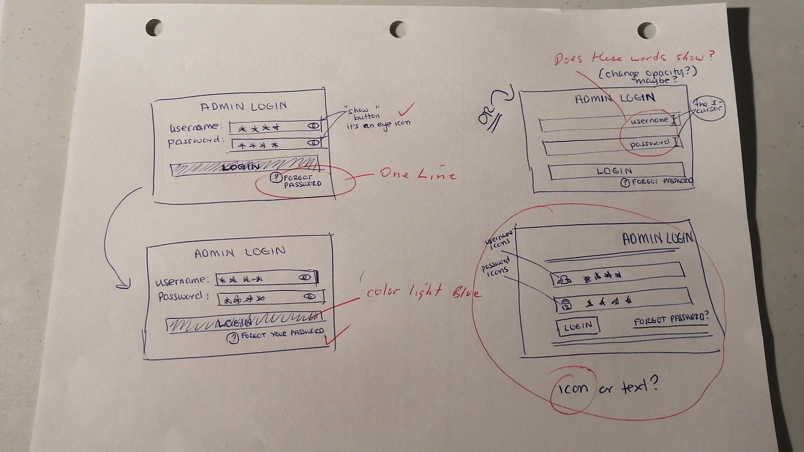

**ADMIN - LOG IN**

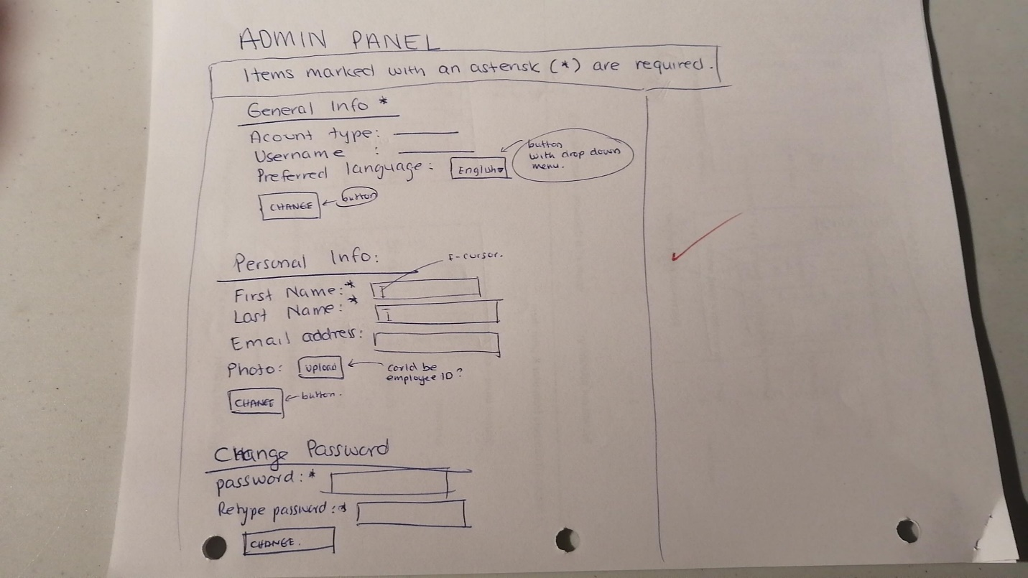

**ADMIN – CREATE ACCOUNT**

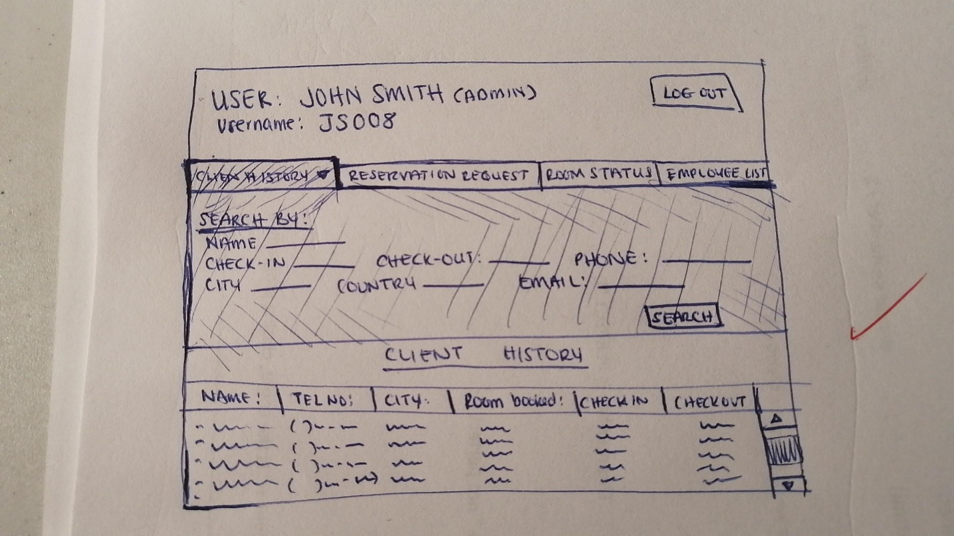

**ADMIN - CLIENT HISTORY**

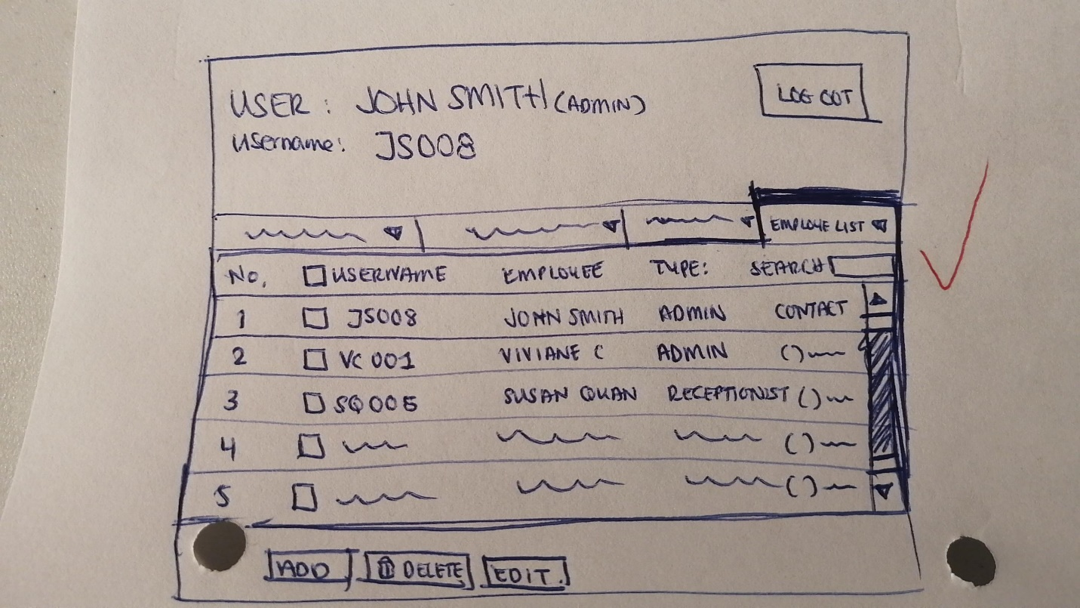

**ADMIN – EMPLOYEE LIST**

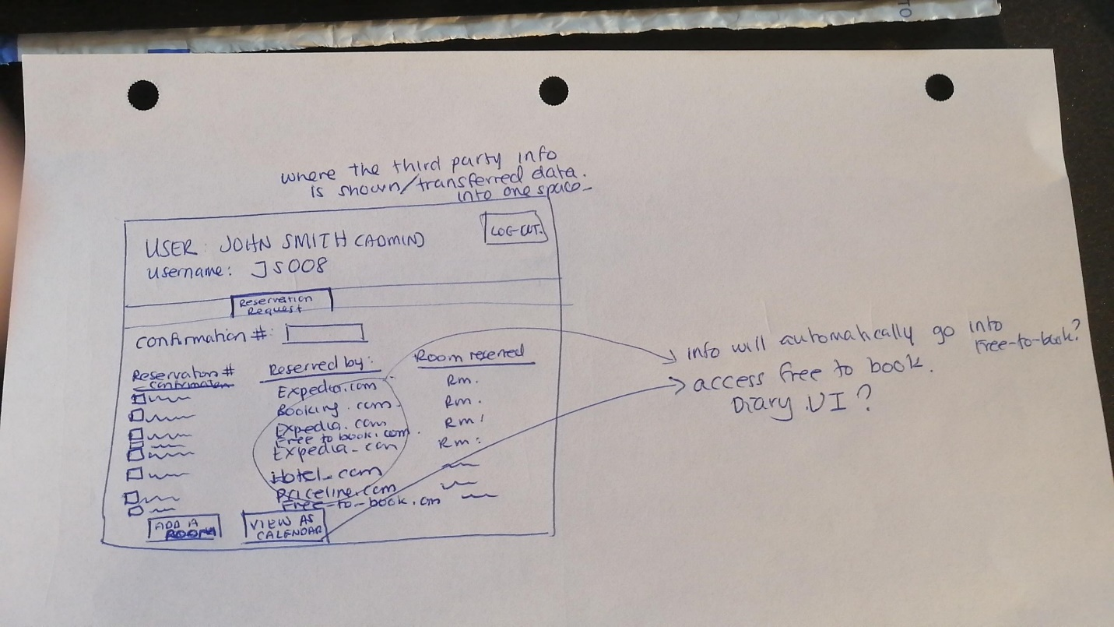

**ADMIN – RESERVATION REQUEST**

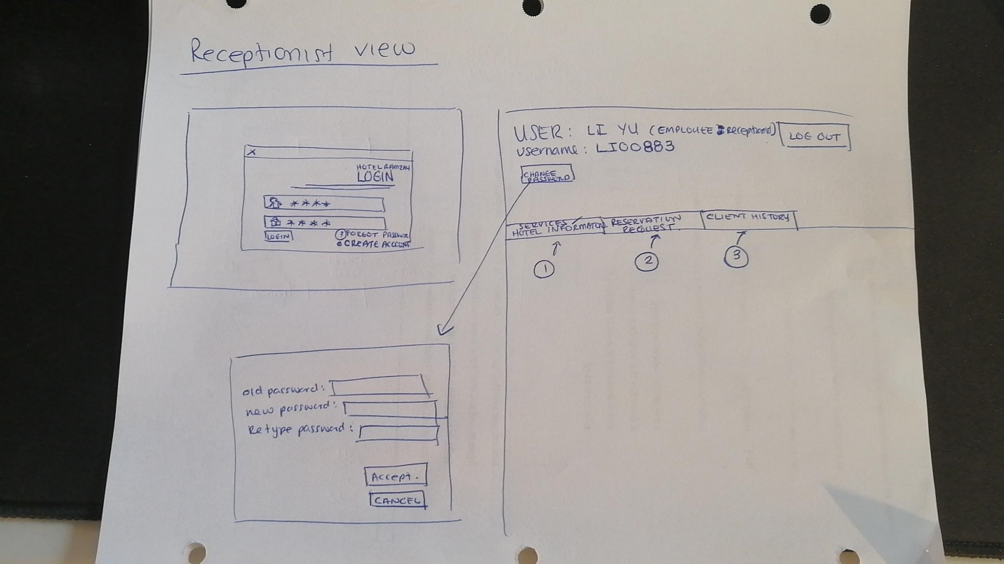

**NON-ADMIN – HOME PAGE ROUGH DRAFT**

Note: Due to time, the client cut the meeting short but agreed for the team to make mock-ups digitally with limited access if used as a non-admin user ie: receptionist.

*Digital Version of prototypes *the blue and pink post-it notes are comments to explain the design\**

**(Log-in, Homepage, Create New Password, Create New Account)**

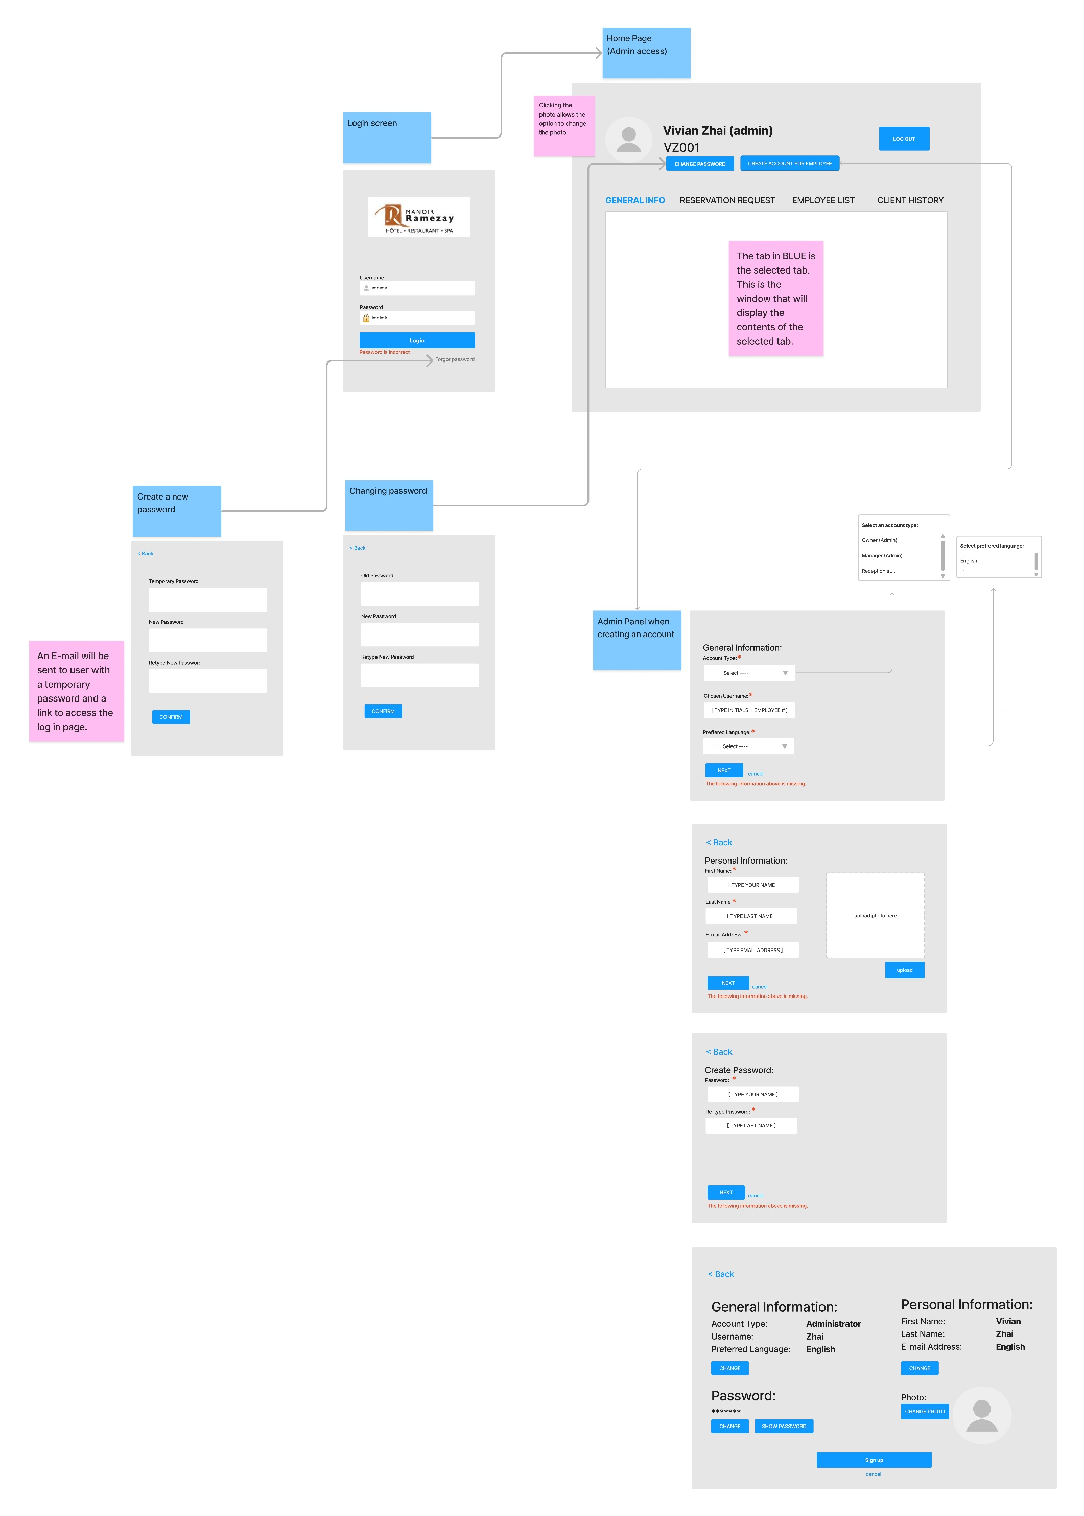

**(General Info Section)**

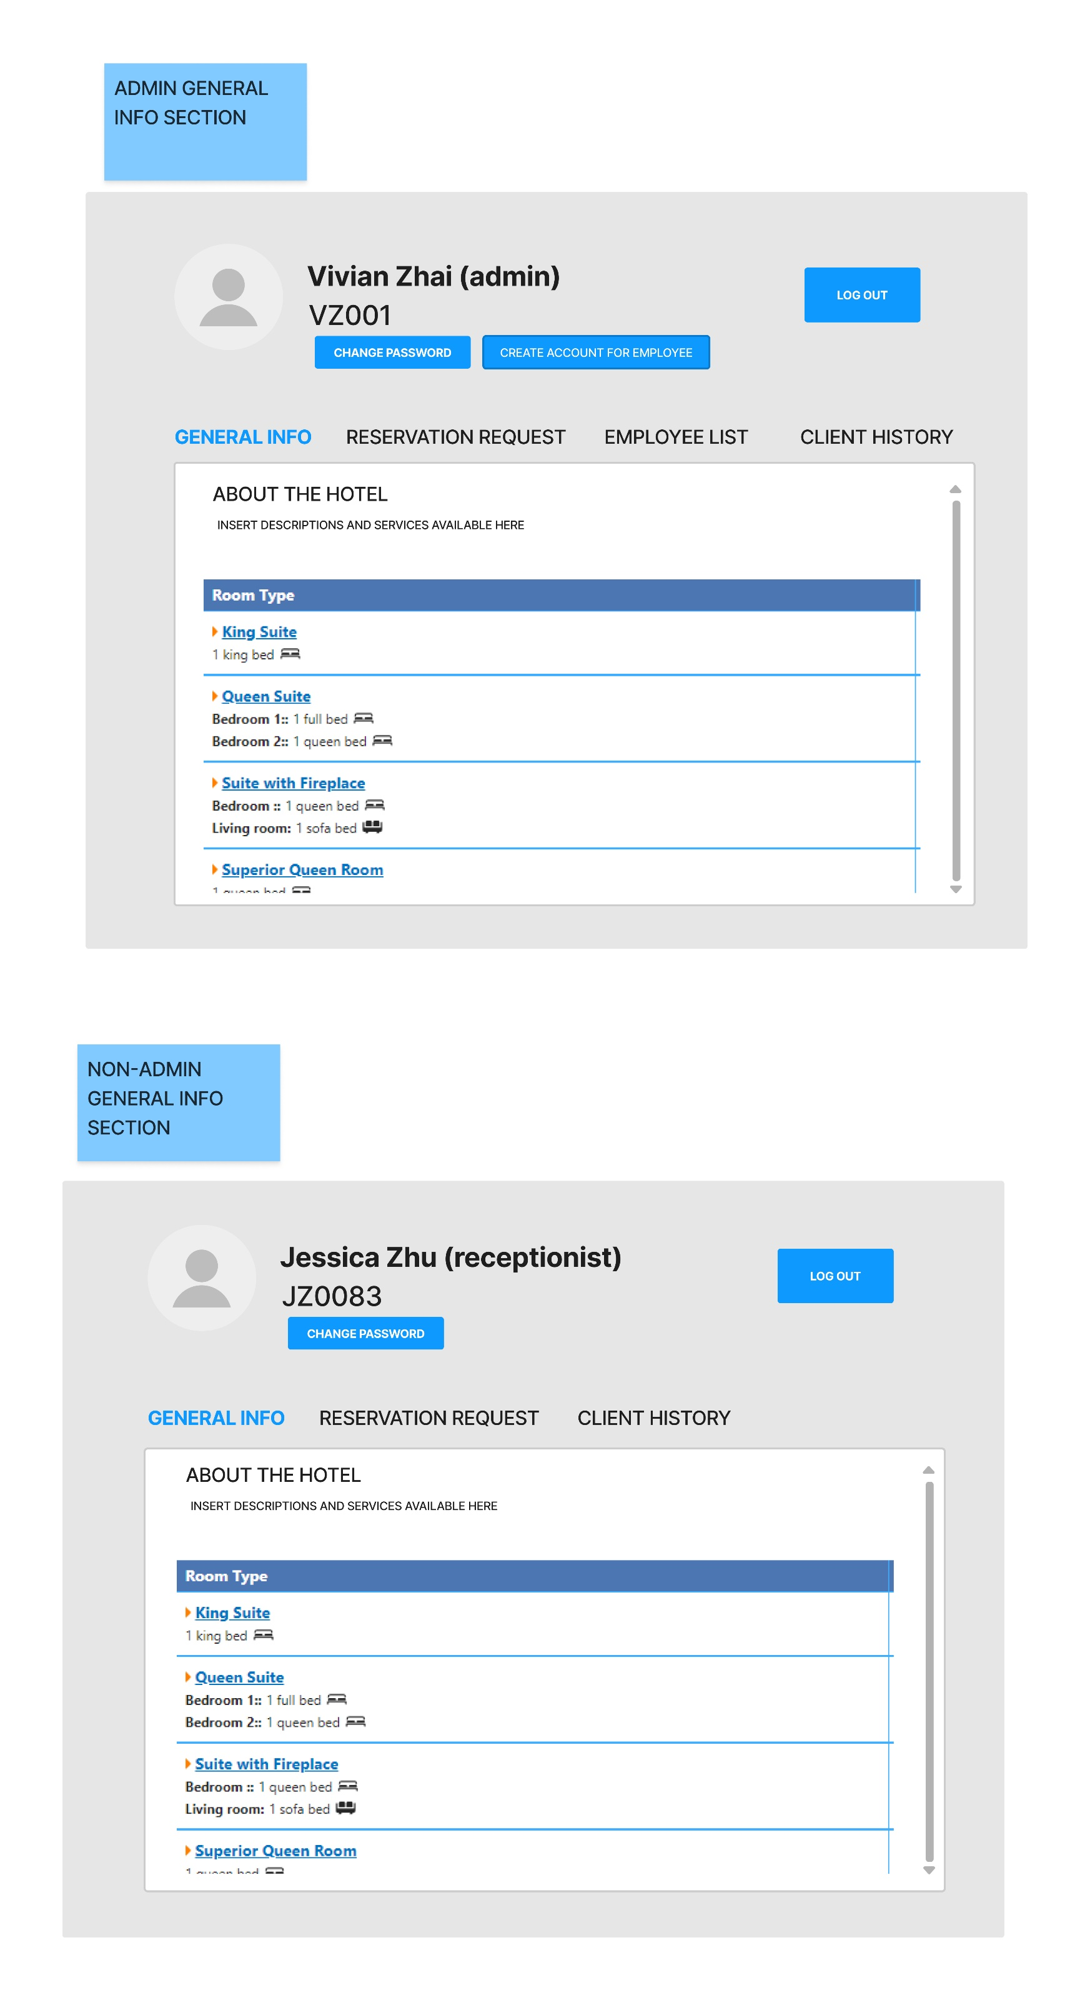

**(Reservation Request Section)**

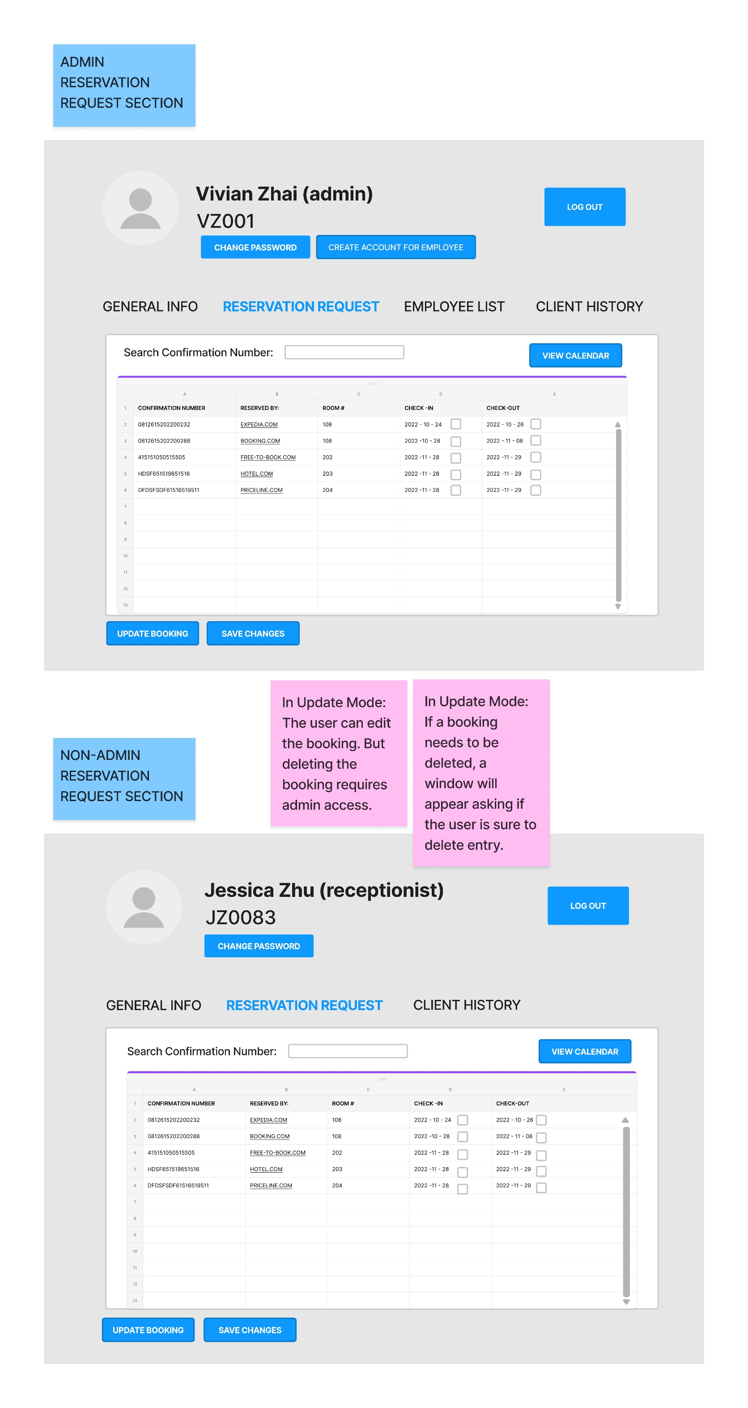

**(Employee List Section)**

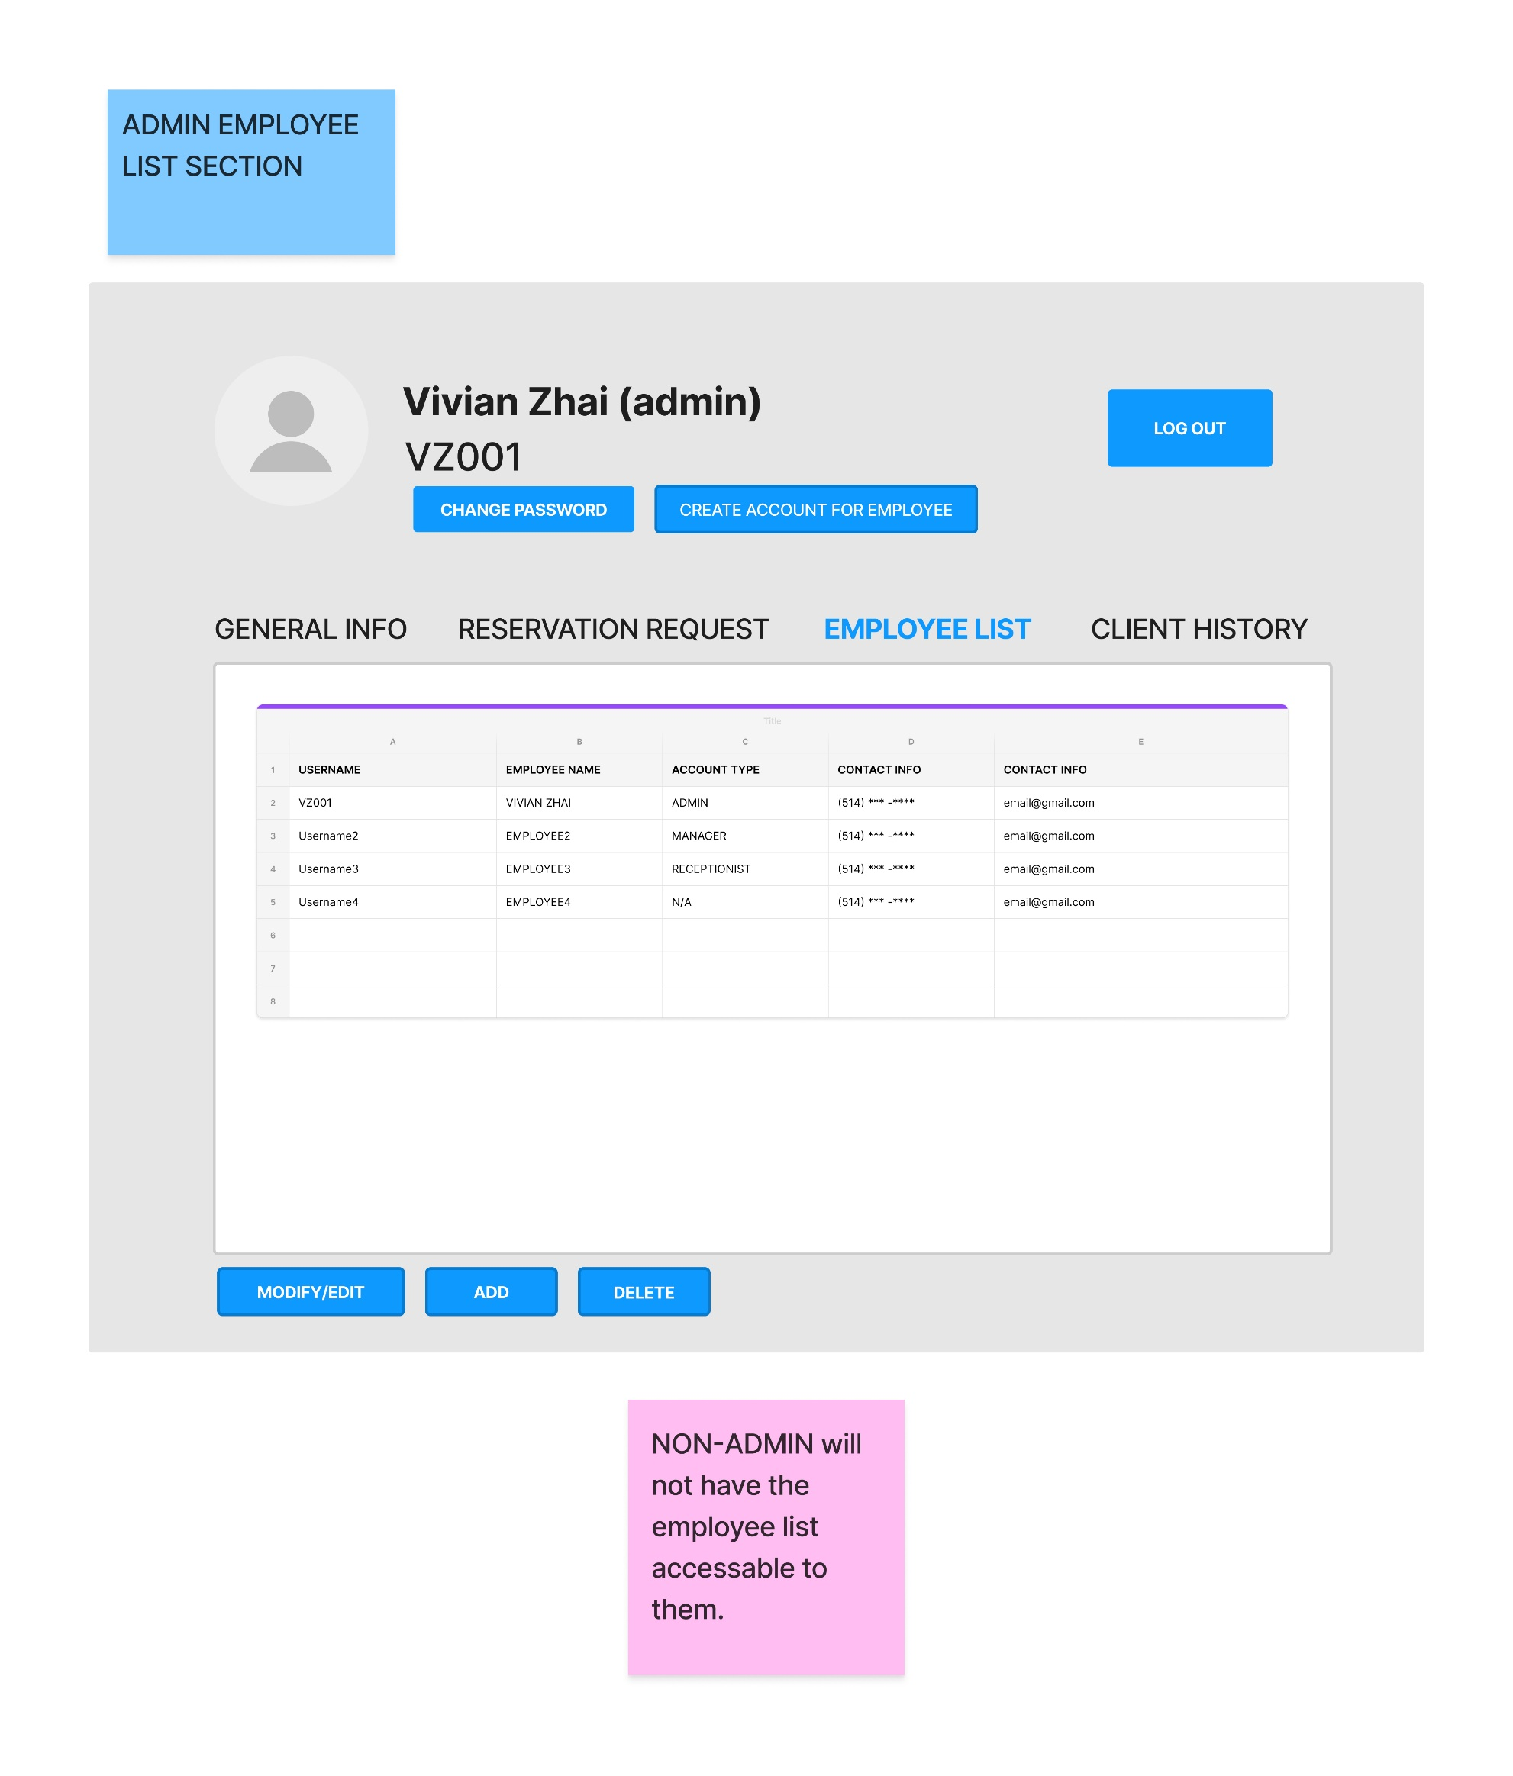

**(Client History Section)**

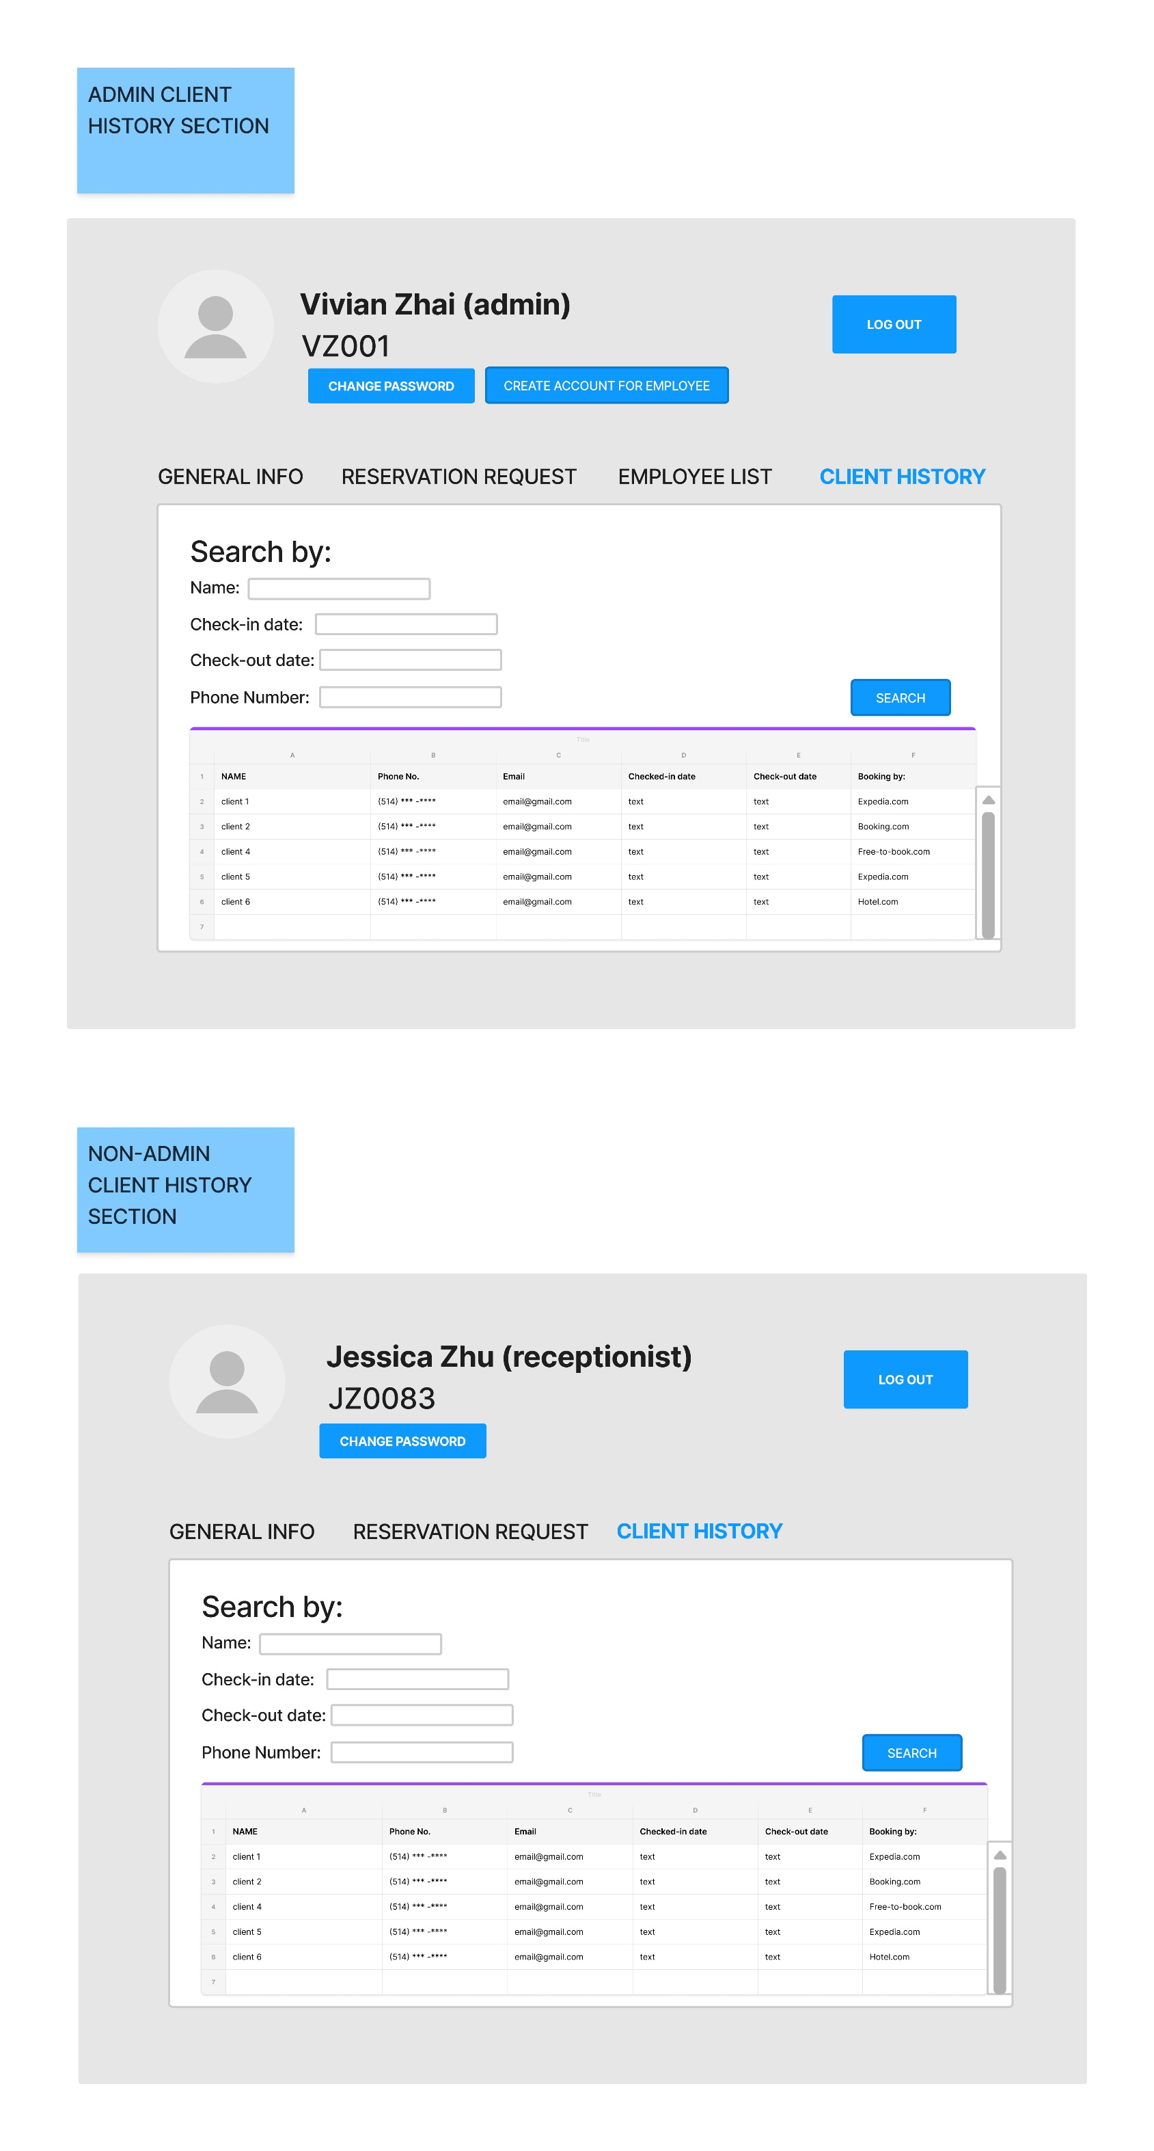

1. **Client Comments**

* **Describe the process used to interact with the client:**

Two of our red team members sat down with the owner to work on the revised user stories, the hand drawn prototypes, and the digitalized prototypes. Questions and answers were exchanged back and forth until there was an agreed upon draft.

* **Client comment on the first prototype (hand-drawn):**

The owners like the system drawings. They are satisfied that employees have different permissions to log in to the system and don’t have full access to it.

They also made their recommendations. First, they would like the system to be very user-friendly since both the staff and the owners are not computer savvy. They want the system to be easy to use, and easy train for the new employees. They don’t want to waste too much time using the system.

Regarding the interface, they want the words and buttons bigger. Also, because they have poor eyesight, they want to see the information more clearly. They also like to have the GUI layout for different screens for ease of use.

* **Client comment on the second prototype (computer-drawn):**

The owners appreciated the second prototype very much. They like the submit button to be a light blue colour that makes it easier to see. They also prefer icons over text during the log-in phase. They stated that it looks professional.

They also recommend the “forgot password” option should be on one line since the owners are worried that there is a function to save the password, so that they don’t need to input the password each time.

1. **Description of Prototype Changes**

In the initial prototype, the words and buttons were a little bit small. The owners have poor eyesight, so they want the words and buttons to be prominent. So, we changed the words to be bigger, and we made the color of the button to be blue. Regarding the client history interface, the owners don’t need a lot of search terms. The most common search terms are the client’s name, check-in date, check-out date, and phone number. Therefore, we removed email, city, and country search terms.

1. **Appendix 1 – Revised User Stories**

The following changes in the User Stories are highlighted in yellow:

The following User Stories that were added are in **BLUE TEXT**:

1. ID: recLogIn

Title: Log In

Story: As a receptionist I would like a unique identifier

1. ID: recSearchGuest

Title: Search Database for Guest

Story: As a receptionist I would like to obtain guest information.

1. ID: recAdd

Title: Add Guests

Story: As a receptionist I would like to add new guest information to the system

1. ID: recModify

Title: Modify Guests

Story: As a receptionist I would like to be able to modify existing guest information.

1. ID: recDelete

Title: Delete Guests

Story: As a receptionist I would like to delete guest records from the unified database

1. ID: recSearchRes

Title: Search Database for Reservation

Story: As a receptionist I would like to obtain reservation information.

1. ID: recCreateRes (THIS WAS MODIFIED)

Title: Create a Reservation

Story: As a receptionist, I would like to be able to create a reservation (All types)

1. ID: recModifyRes

Title: Modify Reservation

Story: As a receptionist, I would like to be able to modify an existing reservation.

1. ID: recDeleteRes

Title: Delete a Reservation

Story: As a receptionist I would like to delete, cancel, or close a reservation.

1. ID: recCalenderView

Title: View All Bookings

Story: As a receptionist I would like to view a calendar of all scheduled reservations.

1. ID: recCheckAvail

Title: Check Room Availability

Story: As a receptionist I would like to be able to verify current room availabilities.

1. ID: recRmAvail

Title: Update Room Availability

Story: As a receptionist I would like room availabilities to be automated.

1. ID: recAddServi (THIS IS NEW)

Title: Add Services

Story: As a receptionist I would like to be able to add a hotel service to an existing reservation.

1. ID: recAddDiscou (THIS IS NEW)

Title: Add Discount

Story: As a receptionist I would like to be able to add a discount to an existing reservation.

1. ID: recSendConf

Title: Send Booking Confirmation

Story: As a receptionist I would like to be able to send booking confirmations.

1. ID: recCheckIn

Title: Check-in

Story: As a receptionist, I would like to be able to check guests in.

1. ID: recKeyCardAct

Title: Activate Room Access Card

Story: As a receptionist I would like to activate a key card.

1. ID: recCheckOut

Title: Check Out

Story: As a receptionist I would like to be able to check guests out.

1. ID: recKeyCardDeac (THIS IS NEW)

Title: Deactivate Room Access Card

Story: As a receptionist I would like to deactivate a key card.

1. ID: recGeneInv

Title: Generate Invoice

Story: As a receptionist I would like to generate a booking invoice.

1. ID: recProPay

Title: Process Payment

Story: As a receptionist I would like to process a client’s payment.

1. ID:recChaPassw (THIS IS NEW)

Title: Change Password

Story: As a receptionist I would like to change my password.

1. ID: recAbort

Title: Exit System

Story: As a receptionist I would like to be able to abort or exit the system.

1. ID: AdminPull

Title: Pull Reports (This Pulls All the Reports)

Story: As a manager I would like to pull occupancy reports from the system.

1. ID: AdminModifCalend (THIS IS NEW)

Title: Modify Calendar

Story: As a manager I would like to modify the calendar based on changes.

1. ID: AdminCreateUser

Title: Create Users

Story: As a manager I would like to be able to create new users.

1. ID: AdminModifyUser

Title: Modify Users

Story: As a manager I would like to modify existing users.

1. ID: AdminDelUser

Title: Delete Users

Story: As a manager I would like to delete users.

1. ID: AdminManagePriv

Title: Manage Privileges

Story: As a manager I would like to manage user privileges.

1. ID: AdminSameAsRec

Title: Preform Receptionist Tasks

Story: As a manager I would like to be able to perform the same tasks as the receptionist.

1. **Appendix 2 – Revised Acceptance Tests**

The following changes in the User Stories are highlighted in yellow:

The following User Stories that were added are in **BLUE TEXT**:

**User Story 1, Title: Log in**

1a. Given that the user is the receptionist

When valid credentials are input

Then he/she has user level access to the system.

1b. Given that the user is the receptionist

When invalid credentials are input

Then he/she does not have any system access.

**User Story 2, Title: Search Database for Guest**

2a. Given that the user is a receptionist

When successfully logged in

And when entering valid guest information within a search field

Then he/she can search the database for the corresponding user.

2b. Given that the user is the receptionist

When entering invalid or non-existent guest information into the input field

Then he/she cannot search the database.

**User Story 3, Title: Add Guests**

3a. Given that the user is the receptionist

When Inputting Guest Information into the system

And the guest is not already present within the system

Then the user is successfully added to the database.

3b. Given that the user is the receptionist

When inputting existing guest detail

Then an error message is displayed

And the guest is not re-added to the database.

**User Story 4, Title: Modify Guests**

4a Given that the user is the receptionist

When a guest record exists in the database

And personal information is changed

Then the user successfully modifies the guest’s information within the database.

4b. Given that the user is the receptionist

When inputting invalid personal information in the input fields

Then an error message is displayed

And the guest’s personal information is not modified.

**User Story 5, Title: Delete Guests**

5a Given that the user is the receptionist

When a guest exists within the system

And when searched via their personal information

And when the delete button is selected and confirmed

Then the user successfully is successfully deleted.

5b. Given that the user is the receptionist

When the guest does not exist within the database

Then the user cannot delete a non-existent guest for the database.

**User Story 6, Title: Search Database for Reservation**

6a. Given that the user is a receptionist

When successfully logged in

And when entering valid guest reservation info within a search field

Then he/she can search the database for the corresponding reservation.

6b. Given that the user is the receptionist

When entering invalid or non-existent reservation information into the search field

Then he/she cannot search the database.

**User Story 7, Title: Create a Reservation (All Reservations here) (New Modifications)**

7a. Given that the user is the receptionist

When successfully logged in

And when having gather the guest’s room and date choices

And when having gathered all required personal and payment information

Then he/she may create a reservation.

7b. Given that the user is the receptionist

When not having gathered all required personal and payment information

Then he/she cannot create a reservation.

**User Story 8, Title: Modify Reservation**

8a. Given that the user is the receptionist

When successfully logged in

And when the reservation in question exists

Then he/she can modify a reservation.

8b. Given that the user is the receptionist

And when the reservation in question does not exist

Then he/she cannot modify a reservation.

**User Story 9, Title: Delete a Reservation**

9a. Given that the user is the receptionist

When successfully logged in

And when the reservation in question exists

Then he/she can delete a reservation.

9b. Given that the user is the receptionist

When the reservation in question does not exist

Then he/she cannot delete a reservation.

**User Story 10, Title: View All Bookings**

10a. Given that the user is the receptionist

When he/she has full access to the system

And when having navigated to the calendar view

Then they may view a calendar of past/present/future bookings.

10b. Given that the user is the receptionist

When input invalid credentials while logging in

Then he/she may not view a calendar of past/present/future bookings.

**User Story 11, Title: Check Room Availability**

11a. Given that the user is the receptionist

When he/she has successfully logged into the system

And when having navigated to the corresponding calendar view

Then he/she can view current room availabilities.

11b. Given that the user is the receptionist

When failing to navigate to the corresponding calendar view

Then he/she cannot view current room availabilities.

**User Story 12, Title: Update Room Availability**

12a. Given that the user is the receptionist

When he/she has successfully logged into the system

And when the systems successfully make API calls to internal booking platforms

Then room availability will be automatically updated.

12b. Given that the user is the receptionist

When a system error occurs

Then an exception message will be shown

And the room availability will not be automatically updated.

**User Story 13, Title: Add Services (THIS IS NEW)**

13a. Given that the user is the receptionist

When is exist a valid reservation

And the guest wishes to add an extra service

Then he/she can add the extra services to the system.

13b. Given that the user is the receptionist

When doesn't exist a valid reservation

Then he/she cannot add extra services to the system.

**User Story 14, Title: Add Discount (THIS IS NEW)**

14a. Given that the user is the receptionist

When a client has an existing reservation

And he/she has a valid promotional discount

Then he/she able to add the discount to the system.

14a. Given that the user the receptionist

When a client has an existing reservation

And doesn't have a valid promotional discount

Then he/she cannot add the discount to the system.

**User Story 15, Title: Send Booking Confirmation**

15a. Given that the user is the receptionist

When successfully logged in

And when a reservation has been successfully created

Then he/she can send booking confirmation

15b. Given that the user is the receptionist

When the manager requests all the booking confirmations

Then he/she can send all the confirmations through the system.

**User Story 16, Title: Check In**

16a. Given that the user is the receptionist

When successfully logged in

And when having gathered all required personal and payment information

And when having made a key card for the guest’s room

Then he/she can check in the guest.

16b. Given that the user is the receptionist

When payment information is missing

Then he/she cannot check in the guest.

**User Story 17, Title: Activate Room Access Card**

17a. Given that the user is the receptionist

When a reservation has been created

And a user checks-in

Then he/she can create the access card to give to the guest

17b. Given that the user is the receptionist

When a guest loses an access card

Then a replacement access card may be granted

And the old access card may be remotely deactivated

**User Story 18, Title: Check Out**

18a. Given that the user is the receptionist

When successfully logged in

And when having gathered processed payment of the guest’s invoice

Then he/she can check out the guest.

18b. Given that the user is the receptionist

When the guest’s invoice has not yet been paid

Then he/she cannot check out the guest.

**User Story 19, Title: Deactivated Room Access Card (THIS IS NEW)**

19a. Given that the user is the receptionist

When a reservation has been terminated

And a guest wants to check-out

Then he/she can deactivate the access card.

19. Given that the user is the receptionist

When a guest loses an access card

Then a replacement access card may be granted

And the old access card may be remotely deactivated

**User Story 20, Title: Generate Invoice**

20a. Given that the user is the receptionist

When he/she has full access to the system

And when a reservation is confirmed

And when the reservation has beginning and end dates

Then he/she can generate a client invoice.

20b. Given that the user is the receptionist

When a reservation is not confirmed

Then he/she cannot generate a client invoice.

**User Story 21, Title: Process Payment**

21a. Given that the user is the receptionist

When he/she has full access to the system

And when a reservation is confirmed

And when all payment information has been gathered

Then he/she may process a guest’s payment.

21b. Given that the user is the receptionist

When payment information has not yet been gathered

Then he/she may not process a guest’s payment.

**User Story 22, Title: Change Password (THIS IS NEW)**

22a. Given that the user is the receptionist

When he/she forgot the password

And wants to change the password immediately

Then he/she can be able to do through the system.

22a. Given that the user is the receptionist

When he/she doesn’t have saucerful log in

And to change the password immediately

Then he/she cannot do it through the system without permission.

**User Story 23, Title: Exit System**

23a. Given that the user is currently using the system

When the user would like to abort or exit the system

And he/she clicks an exit button

Then, they are prompted with a message asking if they are sure they would like to cancel any pending actions

And the system exits.

23b. Given that the user is currently using the system

When the user would like to abort or exit the system

And he/she clicks an exit button

Then, they are prompted with a message asking if they are sure they would like to cancel any pending actions

And if they click no.

Then the system does not exit.

**User Story 24, Title: Pull Reports**

24a. Given that the user is the Administrator

When he/she has access to the system with Administrator credentials

And when they access the booking history view

Then he/she may pull an occupancy report

24b. Given that the user is the Administrator

When logged in without Administrator credentials

Then he/she cannot pull any reports from the system

**User Story 25, Title: Modify Calendar**

25a. Given that the user is the Administrator

When he/she has access to the system

Then he/she can modify the calendar based on the changes.

25b. Given that the user is the Administrator

When he/she does not have access to the system

Then he/she cannot modify the calendar through the system.

**User Story 26, Title: Create Users**

26a. Given that the user is the Administrator

When he/she has access to the system with Administrator credentials

And when all new user information fields have been inputted

Then he/she may create a new user

26b. Given that the user is the Administrator

When he/she has access to the system with Administrator credentials

And the user already exists

Then an error message will be shown

And the Administrator will not be able to create the same user

**User Story 27, Title: Modify Users**

27a. Given that the user is logged in with Administrator credentials.

When there is existing user information.

And when a user information field is changed

Then he/she can modify user information.

27b. Given that the user is the Administrator

When he/she has access to the system without Administrator credentials

Then he/she cannot modify user information.

27c. Given that the is the Administrator

When he/she has access to the system with Administrator credentials

And when the user in question does not yet exist

Then he/she cannot modify user information.

**User Story 28, Title: Delete User**

28a. Given that the user is logged in with Administrator credentials.

When there is existing user information.

Then he/she can delete a user.

28b. Given that the user is the Administrator

When he/she has access to the system without Administrator credentials

Then he/she cannot delete user information.

28c. Given that the user is the Administrator

When he/she has access to the system with Administrator credentials

And when the user in question does not yet exist

Then he/she cannot delete user information.

**User Story 29, Title: Manage privileges.**

29a. Given that the user is the Administrator

When he/she has access to the system with Administrator credentials

And when there is existing user information.

Then he/she can manage user privileges.

29b. Given that the user is the Administrator

When he/she has access to the system without Administrator credentials

Then he/she cannot manage user privileges.

**User Story 30, Title: Preform Receptionist Tasks**

30a. Given that the user is the Administrator

When he/she has full access to the system

Then he/she can perform all the same actions as a receptionist.

30b. Given that the user is not the Administrator

When he/she tries to access the system as Administrator

Then he/she cannot access the system at all.

**The following User Stories and their tests that were removed:**

~~ID: recPhone~~~~Title: Answer the phone   
Story: As a receptionist I would like to be able to answer the phone or make a phone call.~~

~~ID: recGatherInfo   
Title: Gather Guest Information   
Story: As a receptionist I would like to be able to gather guests’ personal information.~~

~~ID: recGatherInfo   
Title: Gather Guest Information    
Story: As a receptionist I would like to be able to gather guests’ payment information.~~

~~ID: recCreateResPhone   
Title: Create a Phone-in Reservation   
Story: As a receptionist, I would like to be able to create a reservation when a guest calls in.~~

~~ID: recCreateResWalkin   
Title: Create a Walk-in Reservation  
Story: As a receptionist, I would like to be able to create a reservation when a guest is present.~~

~~ID: mgrAssign   
Title: Assign Tasks   
Story: As a manager I would like to assign tasks to my employees.~~

**~~User Story, Title: Answer the phone~~** ~~18a. Given that the user is the receptionist   
When he/she answers a phone call   
And the guest wishes to make a reservation   
And all personal and payment information has been gathered   
Then he/she can add the reservation to the system.   
18b. Given that the user is the receptionist   
When he/she are occupied with other requests   
Then he/she cannot create answer the phone~~

**~~User Story, Title: Gather Guest Info~~** ~~19a. Given that the user is the receptionist   
When a client is on the phone or in person   
And when the guest wishes to make a reservation   
Then he/she can gather guest’s personal information.   
19b. Given that the user is not the receptionist   
When not in communication with the client   
Then he/she cannot gather guest’s personal information.~~

**~~User Story, Title: Gather Guest Payment Info~~** ~~20a. Given that the user is the receptionist   
When a client wishes to make a reservation   
And when all other personal information has been gathering for that reservation   
Then he/she can gather guest’s payment information.   
20b. Given that the user is the receptionist   
When personal information for a reservation is not yet gathered   
Then he/she may not gather guest’s payment information.~~

**~~User Story, Title: Assign Tasks~~** ~~|  
25a. Given that the user is the manager   
When he/she has access to the system   
Then he/she can assign tasks to the employees   
25b. Given that the user is the manager   
When he/she does not have access to the system   
Then he/she cannot assign tasks to the employees through the system~~

1. **Appendix 3 – Revised User Story Map**

After deliberation, the red team has concluded that the best tool for mapping user stories is Miro. Miro is an online platform that enables whiteboard collaboration, and distributed teams to work together effectively. Miro has great support brainstorming with digital notes to planning and managing agile workflows. User Story Mapping is one of the patterns it supports, and for which templates are available. Miro’s digital sticky notes are easy to work with, as is arranging the digital sticky notes into a User Story map format. Below the reader will find a User Story map for both roles present in the system, the receptionist, and the manager. The red team did not use all the user stories found in appendix 1 within the User Story map, as some of the task details were overly granular and would have necessitated a further breakdown of what were already fairly simple user stories.

**Revised User Story Map for an Administrative User**

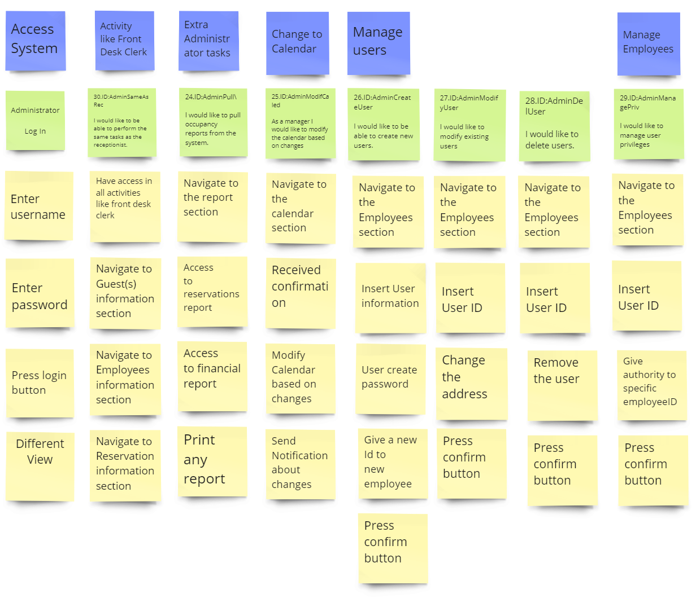

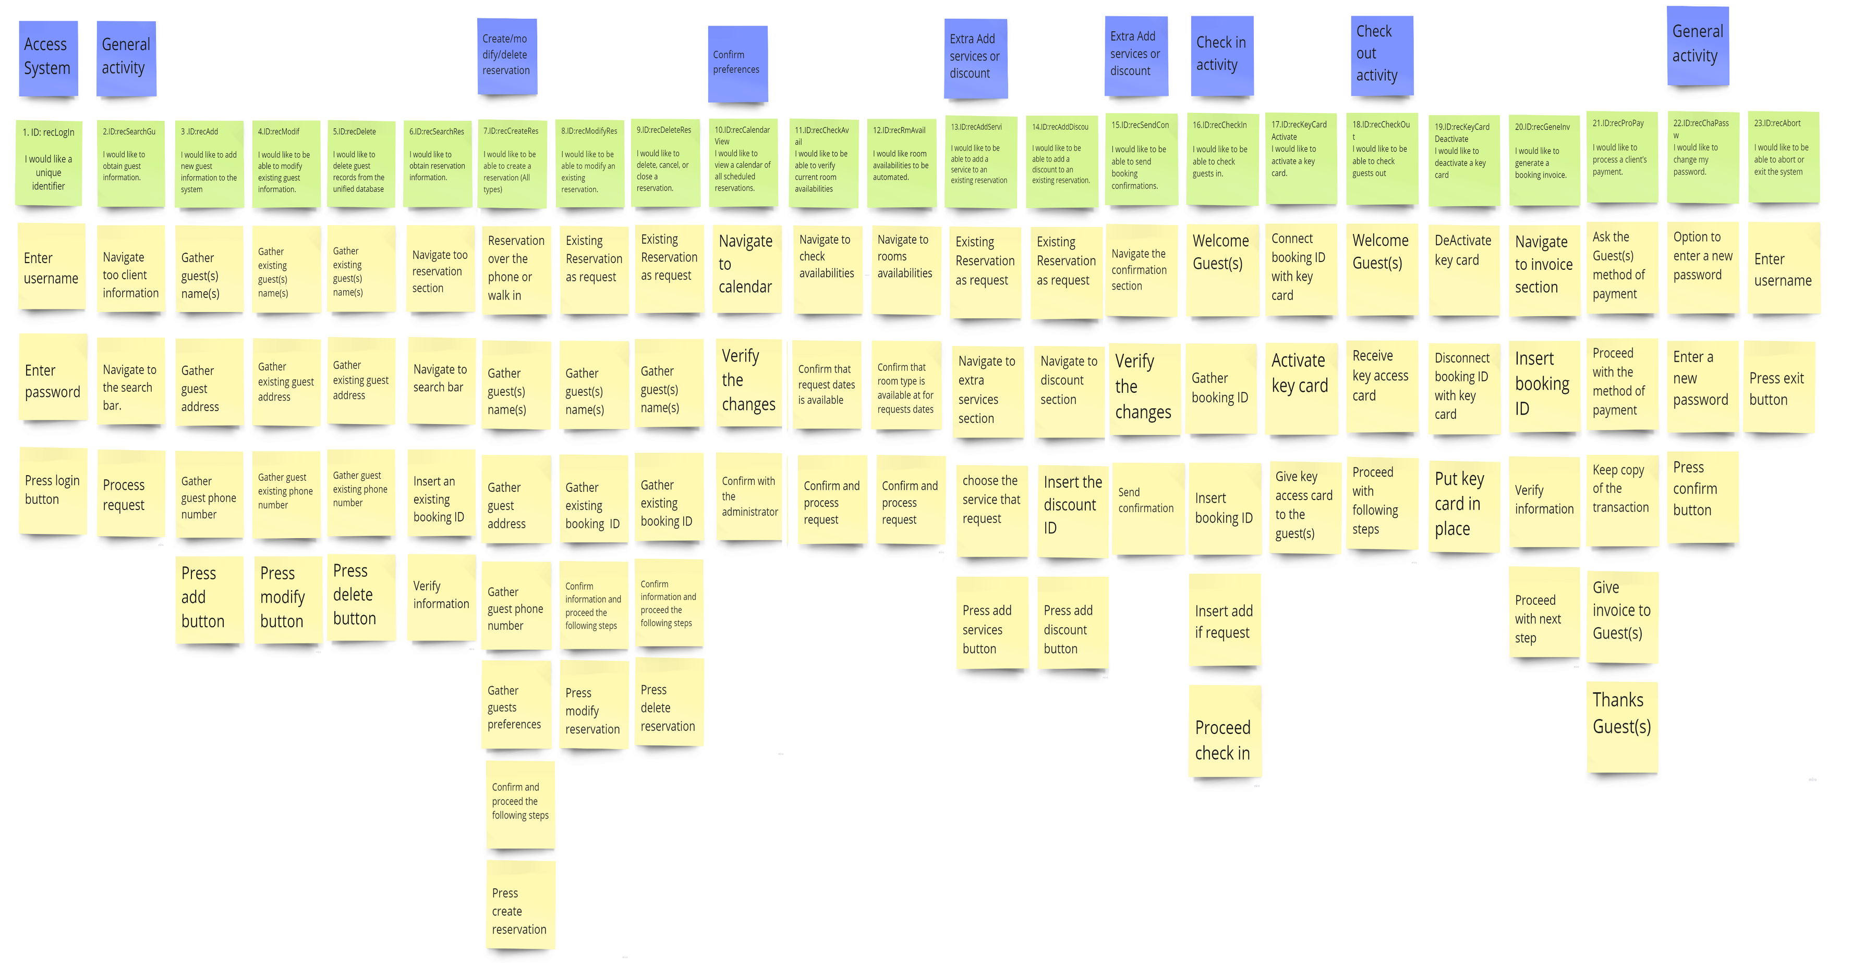 **Revised User Story Map for the Receptionist / Fron-desk clerk**

1. **References**

*9 Principles of Good Web Design*. (2021, November 4). Feelingpeaky - Creative Design Agency, London. Retrieved October 8, 2022, from

Adobe. (2021, July 10). *Adaptive vs Responsive Design & Key Considerations | Adobe XD*. Ideas. Retrieved October 12, 2022, from <https://xd.adobe.com/ideas/process/ui-design/adaptive-design-vs-responsive-design/>

Agile, E. (2021, June 8). Use Cases vs. User Stories: How They Differ and When to Use Them. Easy Agile. Retrieved September 21, 2022, from <https://www.easyagile.com/blog/usecases-vs-user-stories/>

Barraclough, D. (2021, November 18). *11 Worst Web Design Mistakes to Avoid in 2022*. Expert Market. Retrieved October 8, 2022, from <https://www.expertmarket.co.uk/web-design/web-design-mistakes-to-avoid>

Brandenburg, L. (2018, May 25). 3 Situations that are Absolutely Perfect for Use Cases!Bridging the Gap | We’ll Help You Start Your Business Analyst Career. Retrieved September 27, 2022, from <https://www.bridging-the-gap.com/when-would-you-write-a-use-case/>

Dublino, J. (2022, September 30). *12 Tips for Building an Effective Business Website*. Business News Daily. Retrieved October 8, 2022, from <https://www.businessnewsdaily.com/9811-effective-business-website-tips.html>

Jiminez, D. (2022, April 1). *10 Tips That Can Drastically Improve Your Website’s User Experience*. Retrieved October 12, 2022, from <https://blog.hubspot.com/marketing/improve-your-websites-user-experience>

Nickerson, B. (2022, April 28). *12 Web Design Best Practices for 2022*. Tiller. Retrieved October 9, 2022, from <https://tillerdigital.com/blog/12-web-design-best-practices-for-2022/>

Pop, S. A. (2022, May 31). *Essential UI Design Tips for Creating a Good User Interface*. TeleportHQ. Retrieved October 9, 2022, from <https://teleporthq.io/blog/design-tips-for-creating-a-good-user-interface>

Requirements 101: User Stories vs. Use Cases. (2017, October 25). Building Better Software. Retrieved September 21, 2022, from <https://www.stellmangreene.com/2009/05/03/requirements-101-user-stories-vs-use-cases/>

*Top 10 Web-Design Mistakes*. (2021, October 29). [Video]. Nielsen Norman Group. Retrieved October 12, 2022, from <https://www.nngroup.com/videos/top-10-web-design-mistakes>

Varga, D. (2020, November 24). User Story vs Use Case: Everything You Need to Know.DigitalNatives. Retrieved September 21, 2022, from <https://www.digitalnatives.hu/blog/user-story-vs-use-case/>